Answers for lecture 2F

02a.dta. This was a data set of marathon runners. You were asked to summarize age, sex, race time in minutes and favorite running shoe.

Age is continuous and normally distributed (look at a graph or look at the centiles) and so it wouldn’t be unreasonable to describe age in terms of mean and standard deviation (SD) by using “sum age”: mean (42 years), SD of 10.2. By the way, don’t just copy the readout from Stata: this would give mean age as 42.42857 and implies we are interested in age to the nearest five minutes.
Sex is binary: use “tab sex” to get percentages. But note that the person who prepared the data didn’t state how the variable was coded (someone with sex=1 is a woman or a man?). Now what you should do in this situation is ask, but here is another alternative:

sum rt if sex==1

Variable | Obs Mean Std. Dev. Min Max
-------------+-----------------------------------------------------
rt | 32 264.8438 37.44683 222 362

. sum rt if sex==0

Variable | Obs Mean Std. Dev. Min Max
-------------+-----------------------------------------------------
rt | 66 243.2273 49.84709 158 414

So sex==0 are running faster than the sex==1 and it would not be unreasonable to assume that sex==1 means women.

Race time is continuous and look pretty normal. Yes the data are skewed by a single outlier (a race time of 414 minutes) but the mean and median are pretty similar (250 v. 242 minutes) and the 5th and 95th centile are very close to the values expected by adding or subtracting 1.64 times the SD from the mean (5th centile is 170, expected value using means and SD is 173; 95th centile actual and expected values are 327 and 328). I would probably feel comfortable reporting a mean and SD if you wanted.
Favorite running shoe: “sum shoe, detail” gives a mean of 3.08 and a median of 3. If you reported these, you need therapy: shoe is a categorical variable and you should report the percentage of runners that favor each shoe.

AN ADDITIONAL IMPORTANT POINT: you should give the number of observations and the number of missing observations. n is 98 for all observations except for favorite running shoe, where there are 95 observations and 3 missing observations.

So here is a model answer, suitable for publication:

Variable | Number of observations | Mean and SD or number and proportion
Age | 98 | 42 (SD 10.2)
Woman* | 98 | 32 (33%)
Race time in minutes | 98 | 250 (SD 47.1)
Favorite running shoe | 95
Asics | 14 (15%)  7 (7%)  31 (33%)  43 (45%)
New Balance
Nike
Saucony

*assuming 1 is coded as female

However, look at this.

Variable | Number of observations | Median and quartiles or number and proportion
Age | 98 | 43 (34 - 48)
Woman* | 98 | 32 (33%)
Race time in minutes | 98 | 242 (222 - 274)
Favorite running shoe | 95
Asics | 14 (15%)  7 (7%)  31 (33%)  43 (45%)
New Balance
Nike
Saucony

*assuming 1 is coded as female

This really isn't much to distinguish between these tables. On the one hand using the mean and SD gives you more information (e.g. what proportion of patients are aged over 70?). On the other hand, I can't see anyone using a table 1 to do these types of calculation and the median and interquartile range give you some more immediately usable information (no multiplying by 1.64!).

02b.dta. This is data on postoperative pain. You were asked to summarize average pain after the operation. This is continuous, so using “histogram t” you can see that the data look skewed. I would be tempted to use the median (1.8) and quartiles (1.1, 2.6).

However, using the mean and standard deviation doesn’t get you far off. For normal data, 50% of the observations are within two-thirds of a standard deviations of the mean. So the interquartile range predicted from the mean and SD would be 1.9 - 1.1x0.67 and 1.9 + 1.1x0.67 which gives you 1.2 and 2.6. This is an interesting point: the data can look skewed (and if you are interested, a statistical test can tell you that the data are definitely non-normal) but it doesn’t make much of a difference in practice.

You were then asked to imagine that you had to draw a graph of “time course of pain after surgery”. What numbers would you use for time 1, time 2 etc? The first thing to note is that to draw the graph, which seems like a useful thing to do, you have to treat the data as continuous: you can’t really graph a table very easily. This is another illustration of how something that seems technically incorrect gives you useful approximations. Now that we have continuous data we have to decide whether to use medians or means. As it turns out, normality of the data isn’t even an issue. Here is what happens if you graph the median pain score at each time point.

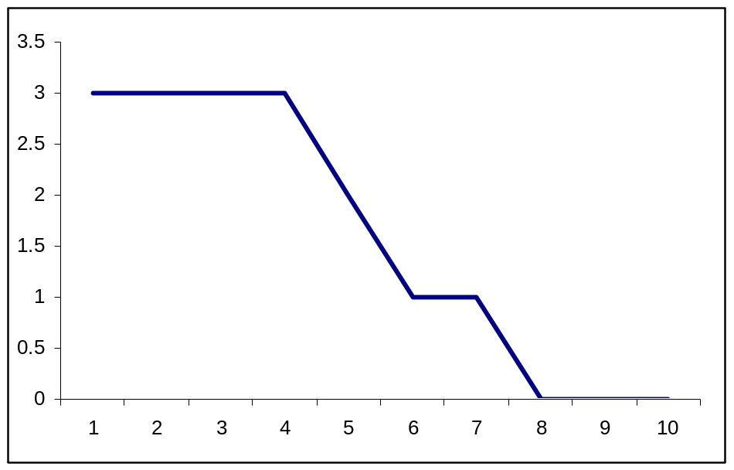

This makes it seem that postoperative pain doesn’t change for four time points, then drops dramatically.

A graph using means seems more illustrative of what is really going on.

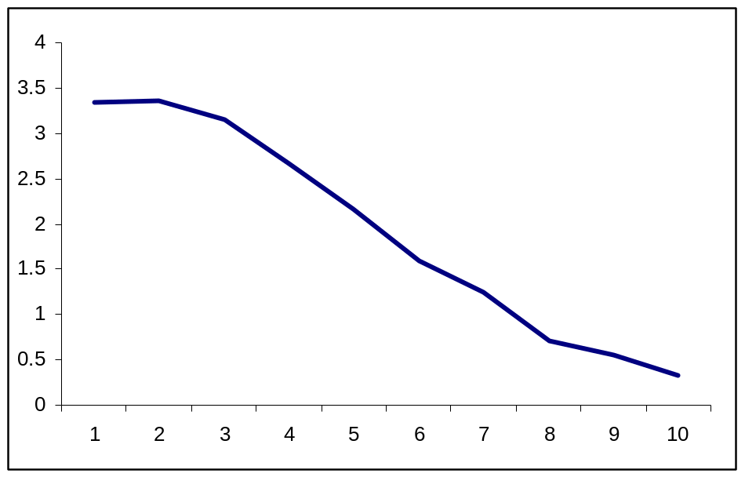

02c.dta. Characteristics of a radical prostatectomy cohort. One of the first things to look for here is missing data. If you just type “sum” or “inspect” you’ll see that there is no missing data for age, 9 missing observations for PSA and 41 for grade. It looks like all observations are missing for stage, but this is because it is a string variable. If you type “tab stage”, you’ll see that all 241 patients have a stage assigned. A second issue is how to characterize the categorical variables. There are 8 different stages represented, many with very small numbers (like 2 for T4 and T1B, 4 for T3). It generally isn’t very helpful to slice and dice data into very small categories, so I would consider grouping. For instance, we could group the T1s and T3 and 4 to get something like:

Stage | Number (%)
T1 | 169 (70%)
T2A | 36 (15%)
T2B | 22 (9.1%)
T2C | 8 (3.3%)
T3/4 | 6 (2.5%)

To get the table, I created a new variable as follows

g stage_category=stage
replace stage_category="T1" if stage=="T1A" | stage=="T1B" | stage=="T1C"
replace stage_category="T3/4" if stage=="T3" | stage=="T4"
tab stage_category

There is a similar issue for grade, with few patients having grades 4, 5, 8 or 9. Now a key point is that what you decide to do in situations like this will often need to take into account your medical understanding. It might seems sensible to categorize grade as ≤6 or ≥7, or perhaps 4/5, 6, 7, 8/9. But as it turns out in prostate cancer, pathologists can’t reliably grade a cancer as 4 or 5 and these cancers should really be grouped with grade 6. Grade 8, on the other hand, signifies very aggressive disease and really needs to be reported separately even if there are only a few patients with grade 8. So grade would probably be summarized as per the following table:

Variable | Number (%) or median (quartiles)
Stage
T1 | 169 (70%)
T2A | 36 (15%)
T2B | 22 (9.1%)
T2C | 8 (3.3%)
T3/4 | 6 (2.5%)
Grade (N=200)
6 | 79 (40%)
7 | 112 (56%)
8 | 9 (4.5%)
Age | 60 (56, 65)
PSA (N=232) | 5.3 (4.0, 8.0)

02d.dta. Cost of a minor medical procedure. I asked you to summarize the cost. You can see from a graph. If we were to follow the rule book slavishly, we would report a median and interquartile range. But what use is a median for cost data? We want to know “average” cost so that we can predict, for example, how much we should budget for next year. This requires a mean.

02e.dta. Summarize total cancer pain in one month in a group with chronic cancer pain.

The data are grossly non-normal and you could use the median pain score with interquartile range.

As for summarizing the number of days in pain, almost everyone has 31 days of pain. So I would give proportions of patients who had pain for 31 days and then the number who, say, had pain at least 3 out of every 4 days and 2 out of 4 days. There are two ways of doing this. You could just type “tab f” and then combine some of the results. Or, and this is a little more complicated, you could create a new variable.

g days=0
replace days=1 if f>15
replace days=2 if f>23
replace days=3 if f==31

In other words, create a new variable called “days” and set it to zero. Call anyone who has pain more than half the time (i.e. more than 15 days) a 1. Call anyone who has pain more than three quarter of the time (i.e. more than 23 days) a 2. Call anyone who has pain all the time a 3. However, you have to be careful, because some patients have missing data for number of days with pain. So you have to add a line to make your new variable is missing when number of days with pain is missing:

replace days=. if f==.

Then type “tab days” to get:

days | Freq. | Percent | Cum.
0 | 16 | 17.02 | 17.02
1 | 7 | 7.45 | 24.47
2 | 23 | 24.47 | 48.94
3 | 48 | 51.06 | 100.00
Total | 94 | 100.00
So you could report that, of the 94 patients with data on number of days with pain, 51% were in daily pain, 17% of patients had pain on less than half of days, 7% of patients had pain on more than half but less than 75% of days, 24% of patients had pain on more than 75% of days, but not every day.
FOR KEEN STUDENTS ONLY!
You could also try a log transformation of the pain scores. Create a new variable by typing: g log=log(pain)

Analyze this variable and you’ll see it appears normally distributed.

The mean of log is 5.4. You can transform the log back by calculating e^{5.4} (the command in Stata is “disp exp (5.4)”) to get 223, quite close to the median. Backtransforming the standard deviation is more complicated and can’t really be done directly. What you need to do is make any calculations you need on the log transformed scale and then backtransform the results. Imagine you wanted a 95% confidence interval. A 95% confidence interval is the mean ± 1.96 standard deviations. The standard deviation of the log data is close to one. So the confidence interval is 3.76 to 7.04. Transforming this exp(3.76) and exp(7.04) gives a confidence interval on the original scale of 43 and 1141. This is a reasonable approximation to the 5th (47) and 95th centile (1379).

